Activity 7

1. Write a Python program that will display numbers 50 to 1 using While Loop Function.

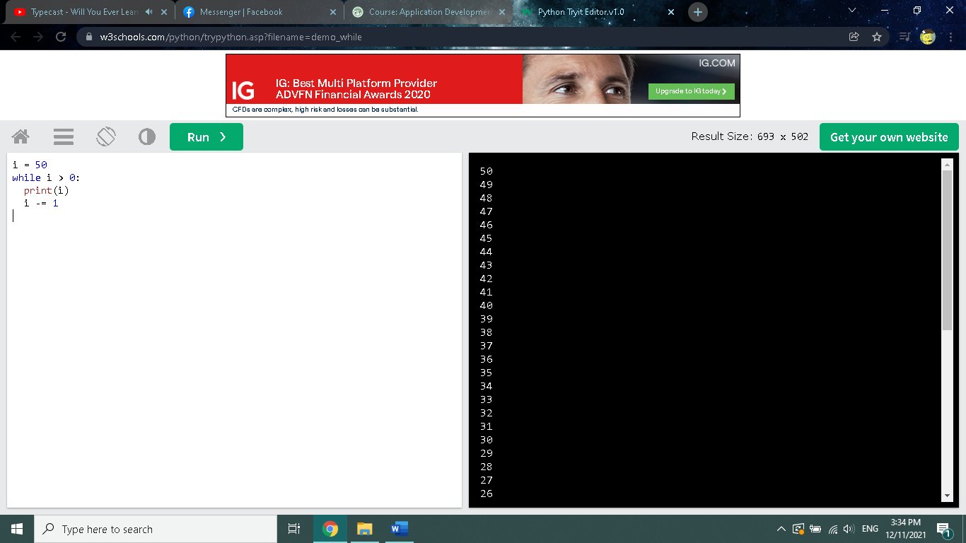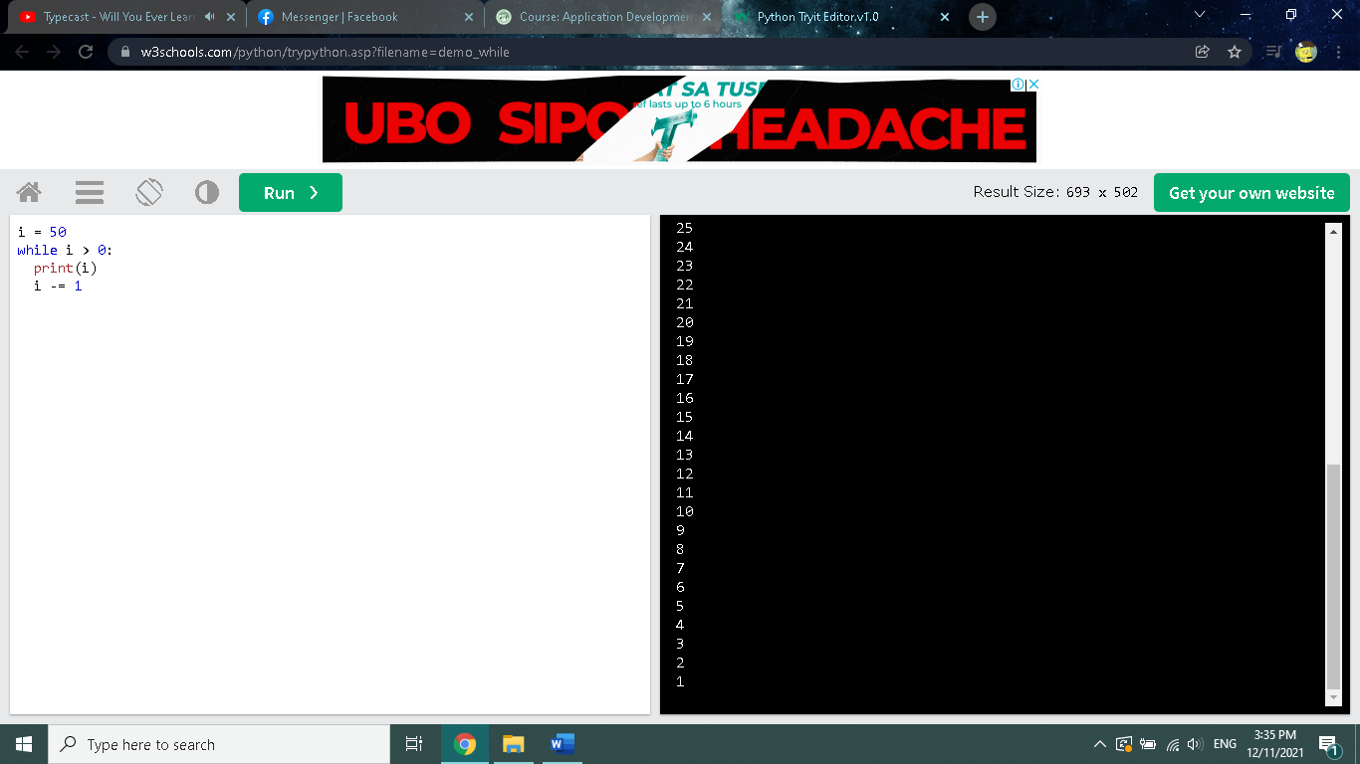

i = 50

while i > 0:

print(i)

i -= 1